# 

# WATER QUALITY MONITORING SYSTEM

**Project Journal**

# 

# 

# 

# 

# 

# 

# 

# 

# 

# Introduction:

Water quality monitoring is a critical aspect of environmental stewardship and public health protection. With growing concerns over pollution, climate change, and population growth, ensuring the safety and sustainability of our water resources has become increasingly imperative. Through systematic monitoring efforts, scientists, policymakers, and stakeholders can track the chemical, physical, and biological parameters of water bodies, identifying potential contaminants and assessing the overall health of aquatic ecosystems.

As stated by the World Health Organization (WHO), access to clean water is essential for human health and well-being, yet millions of people worldwide lack access to safe drinking water due to pollution and inadequate sanitation infrastructure. Additionally, the United Nations Environment Programme (UNEP) highlights the importance of monitoring water quality to address emerging threats such as microplastic pollution and pharmaceutical residues, which can have adverse impacts on aquatic organisms and human health.

Moreover, reputable sources like the Environmental Protection Agency (EPA) emphasize the significance of water quality monitoring in supporting regulatory compliance and guiding effective management strategies for water resources. By staying vigilant and proactive in monitoring water quality, we can better understand the challenges facing our waterways and take appropriate measures to protect and sustain them for future generations.

Researchers have long been interested in understanding how to effectively monitor water quality to ensure its safety and sustainability. Some common research questions in this area include: How can we accurately measure and assess the quality of water? What are the main sources of pollution in water bodies, and how can we mitigate them? How do changes in land use, climate, and human activities impact water quality over time?

To address these questions, researchers have developed various monitoring systems and technologies. For example, they use sensors and sampling methods to collect data on parameters such as pH, temperature, dissolved oxygen, and pollutants. They also analyze water samples in laboratories to detect contaminants and assess overall water quality. Additionally, researchers use computer models to simulate and predict the behavior of water systems under different scenarios, helping policymakers make informed decisions about water management and conservation. Through ongoing research and innovation, scientists continue to refine and improve water quality monitoring systems to better protect our precious water resources.

In our research, we are focusing on the development and implementation of a novel approach to water quality monitoring using turbidity, Total Dissolved Solids (TDS), pH, and temperature sensors. While existing methods often rely on individual sensors to measure specific parameters, our approach combines multiple sensors into an integrated monitoring system. This allows us to gather comprehensive data on various aspects of water quality simultaneously, providing a more holistic understanding of aquatic ecosystems.

Moreover, our method incorporates real-time data transmission and analysis capabilities, enabling continuous monitoring and rapid response to changes in water quality. By leveraging advances in sensor technology and data processing algorithms, we aim to enhance the accuracy, efficiency, and scalability of water quality monitoring efforts. Ultimately, our research contributes to the development of innovative tools and techniques for assessing and managing water resources, with potential applications in environmental monitoring, water treatment, and ecosystem conservation.

In our research, we utilize a combination of turbidity, Total Dissolved Solids (TDS), pH, and temperature sensors to monitor water quality. These sensors are integrated into a comprehensive monitoring system, allowing us to simultaneously measure multiple parameters in real-time. This approach differs from traditional methods, which often rely on separate sensors for each parameter and may not provide continuous monitoring capabilities. By consolidating multiple sensors into a single system, we can streamline data collection and analysis processes, facilitating more efficient and effective water quality monitoring.

Our main results indicate that our integrated sensor system provides accurate and reliable measurements of turbidity, TDS, pH, and temperature in various water bodies. By analyzing the data collected from these sensors, we can gain valuable insights into the quality and health of aquatic ecosystems. Furthermore, our research demonstrates the potential of using machine learning methods to predict water quality based on sensor data. By training predictive models on historical data, we can develop algorithms capable of forecasting water quality parameters and identifying potential pollution events or environmental changes in advance. This predictive capability has significant implications for water resource management, allowing stakeholders to proactively address water quality issues and implement timely interventions to protect human health and ecosystem integrity. Overall, our findings underscore the importance of integrated sensor systems and machine learning techniques in advancing water quality monitoring and management practices.

# Background:

Water quality monitoring is a critical aspect of environmental management, ensuring the safety and sustainability of water resources. In recent years, advancements in sensor technology and Internet of Things (IoT) have revolutionized the way water quality is monitored and assessed. Our project focuses on developing a comprehensive water quality monitoring system utilizing sensors for Total Dissolved Solids (TDS), temperature, pH, and turbidity. This system aims to provide real-time data on key water quality parameters, enabling efficient monitoring and management of water resources.

Be sure to include references.

The water quality monitoring system integrates sensors for TDS, temperature, pH, and turbidity with an Arduino microcontroller. Each sensor is responsible for measuring specific parameters: TDS sensor measures the concentration of dissolved solids in water, temperature sensor measures the water temperature, pH sensor measures the acidity or alkalinity of the water, and turbidity sensor measures the cloudiness or clarity of the water. The Arduino collects data from these sensors and transmits it wirelessly to ThingSpeak, a cloud-based IoT platform, using the ESP32 as a WiFi module. ThingSpeak then processes the data and generates visualizations for monitoring and analysis.

Our water quality monitoring system is used for monitoring various water bodies such as rivers, lakes, reservoirs, and groundwater. It finds applications in environmental monitoring, water resource management, agriculture, aquaculture, and industrial processes. By providing real-time data on water quality parameters, the system enables stakeholders to make informed decisions regarding water usage, pollution control, and environmental conservation efforts.

Effective water quality monitoring is essential for safeguarding public health, protecting ecosystems, and supporting sustainable development. By continuously monitoring key water quality parameters such as TDS, temperature, pH, and turbidity, our system helps identify potential sources of pollution, detect environmental changes, and assess the overall health of water bodies. This information is crucial for implementing appropriate remediation measures, ensuring compliance with regulatory standards, and promoting the sustainable management of water resources for future generations.

# Methodological Overview:

The project involves monitoring water quality parameters such as temperature, TDS (Total Dissolved Solids), and pH using sensors connected to an Arduino board. The collected data is then transmitted to an ESP32 for further processing and eventual transmission to a data logging platform like ThingSpeak. The methodological approach consists of initializing sensors, reading sensor data periodically, processing the data, and transmitting it to the ESP32 and ThingSpeak.

‘

Flowchart:

The flowchart illustrates the process of the water quality monitoring system. Inputs include sensor readings for temperature, TDS, and pH, while outputs consist of data sent to both the local serial terminal and ThingSpeak platform.

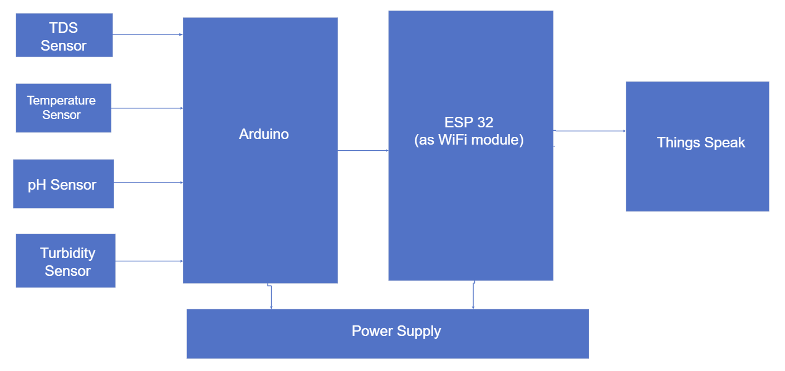

Data:

Data Source

Temperature DS18B20 temperature sensor

TDS CQRobotTDS sensor

pH pH sensor

Data Collection:

Temperature data is obtained from a DS18B20 temperature sensor, TDS data from a CQRobotTDS sensor, and pH data from a pH sensor. These sensors interface with an Arduino board, which reads analog values and converts them to meaningful measurements.

Data is collected using Arduino's analogRead function, which reads voltage values from sensors, followed by conversion to physical units using sensor-specific conversion equations.

The collected data is in raw analog voltage or digital form, requiring conversion to meaningful units such as °C for temperature, ppm for TDS, and pH for pH level.

Data cleaning involves filtering out noise or outliers in sensor readings to ensure accurate measurements. This may include averaging multiple readings or applying calibration values to compensate for sensor inaccuracies.

Data Analysis:

Data analysis involves interpreting the collected sensor data to assess water quality parameters. For example, trends in temperature, TDS, and pH levels over time can be analyzed to identify patterns or anomalies indicative of water quality changes.

Model:

The model used in this project involves interfacing with sensors, processing raw sensor data, and transmitting the processed data to an ESP32 for further processing and transmission to ThingSpeak.

Objective Function: Transmit water quality data to ThingSpeak platform.

Sets: Sensor data (temperature, TDS, pH).

Parameters: Calibration values, sensor pins.

Decision Variables: None.

Constraints: Time constraints for data transmission.

This model is based on a typical sensor data acquisition and transmission system commonly used in IoT (Internet of Things) applications. The formulation is straightforward, focusing on data acquisition, processing, and transmission steps. No significant changes are made to the existing model, as it aligns well with the project requirements.

In the initial stages of our project, we embarked on integrating a circuit comprising pH, TDS (Total Dissolved Solids), turbidity, and temperature sensors, utilizing an ESP32 microcontroller and programming it through the Arduino IDE. However, we encountered a significant hurdle regarding accuracy, particularly with the turbidity sensor. This hiccup arose due to the voltage discrepancy between the ESP32, operating at 3.3 volts, and the turbidity sensor requiring 5 volts. Despite our efforts to address this issue, the readings obtained were consistently inaccurate, prompting us to seek an alternative solution.

After careful consideration, we transitioned to using an ESP32 NodeMCU, which offered compatibility with both 3.3-volt and 5-volt sensors. While this adjustment positively impacted the accuracy of the turbidity readings, we encountered unexpected complications affecting the performance of the other sensors. This setback underscored the intricate interplay between various components within the circuit and the necessity for a comprehensive approach to calibration and optimization.

Ultimately, we achieved success by reconfiguring our setup to incorporate all four sensors within the Arduino IDE environment, leveraging the ESP32 solely as a Wi-Fi module for data transmission. This approach allowed us to focus on fine-tuning each sensor individually for optimal accuracy while ensuring seamless integration and minimal interference between components. The outcome of this iterative process was a robust and reliable sensor system capable of delivering high-precision measurements across multiple parameters, demonstrating the importance of adaptability and persistence in tackling engineering challenges.

Circuitry:

All the connections are made by interfacing Arduino UNO and ESP 32 to the sensors. The transmitter and receiver of ESP 32 are connected to the 2nd and 3rd pins of arduino UNO as transmitter and receiver respectively. The data pins of the sensors are connected from A0 to A5 of the arduino UNO. The ground and VPP are taken from Arduino UNO. All the sensors ground and VPP are connected on the breadboard by shorting the connection with the arduino’s VPP and ground. A pullup resistor is connected on the breadboard, one side of the resistor is connected to the data pin of the temperature sensor.

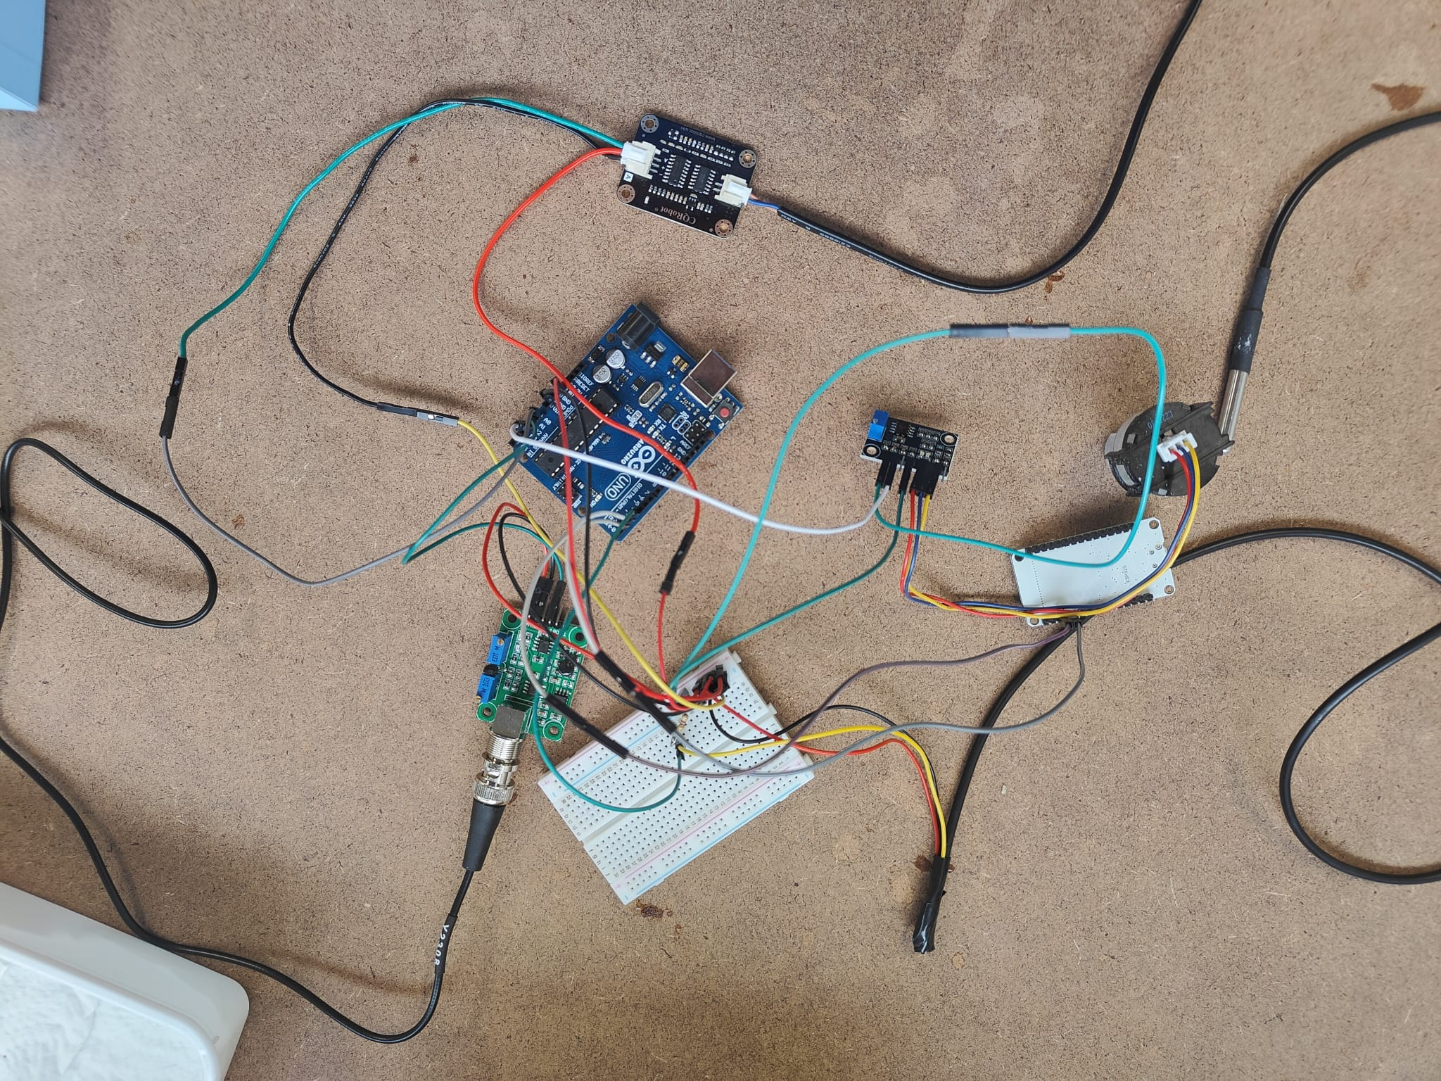

Figure1: Circuitry

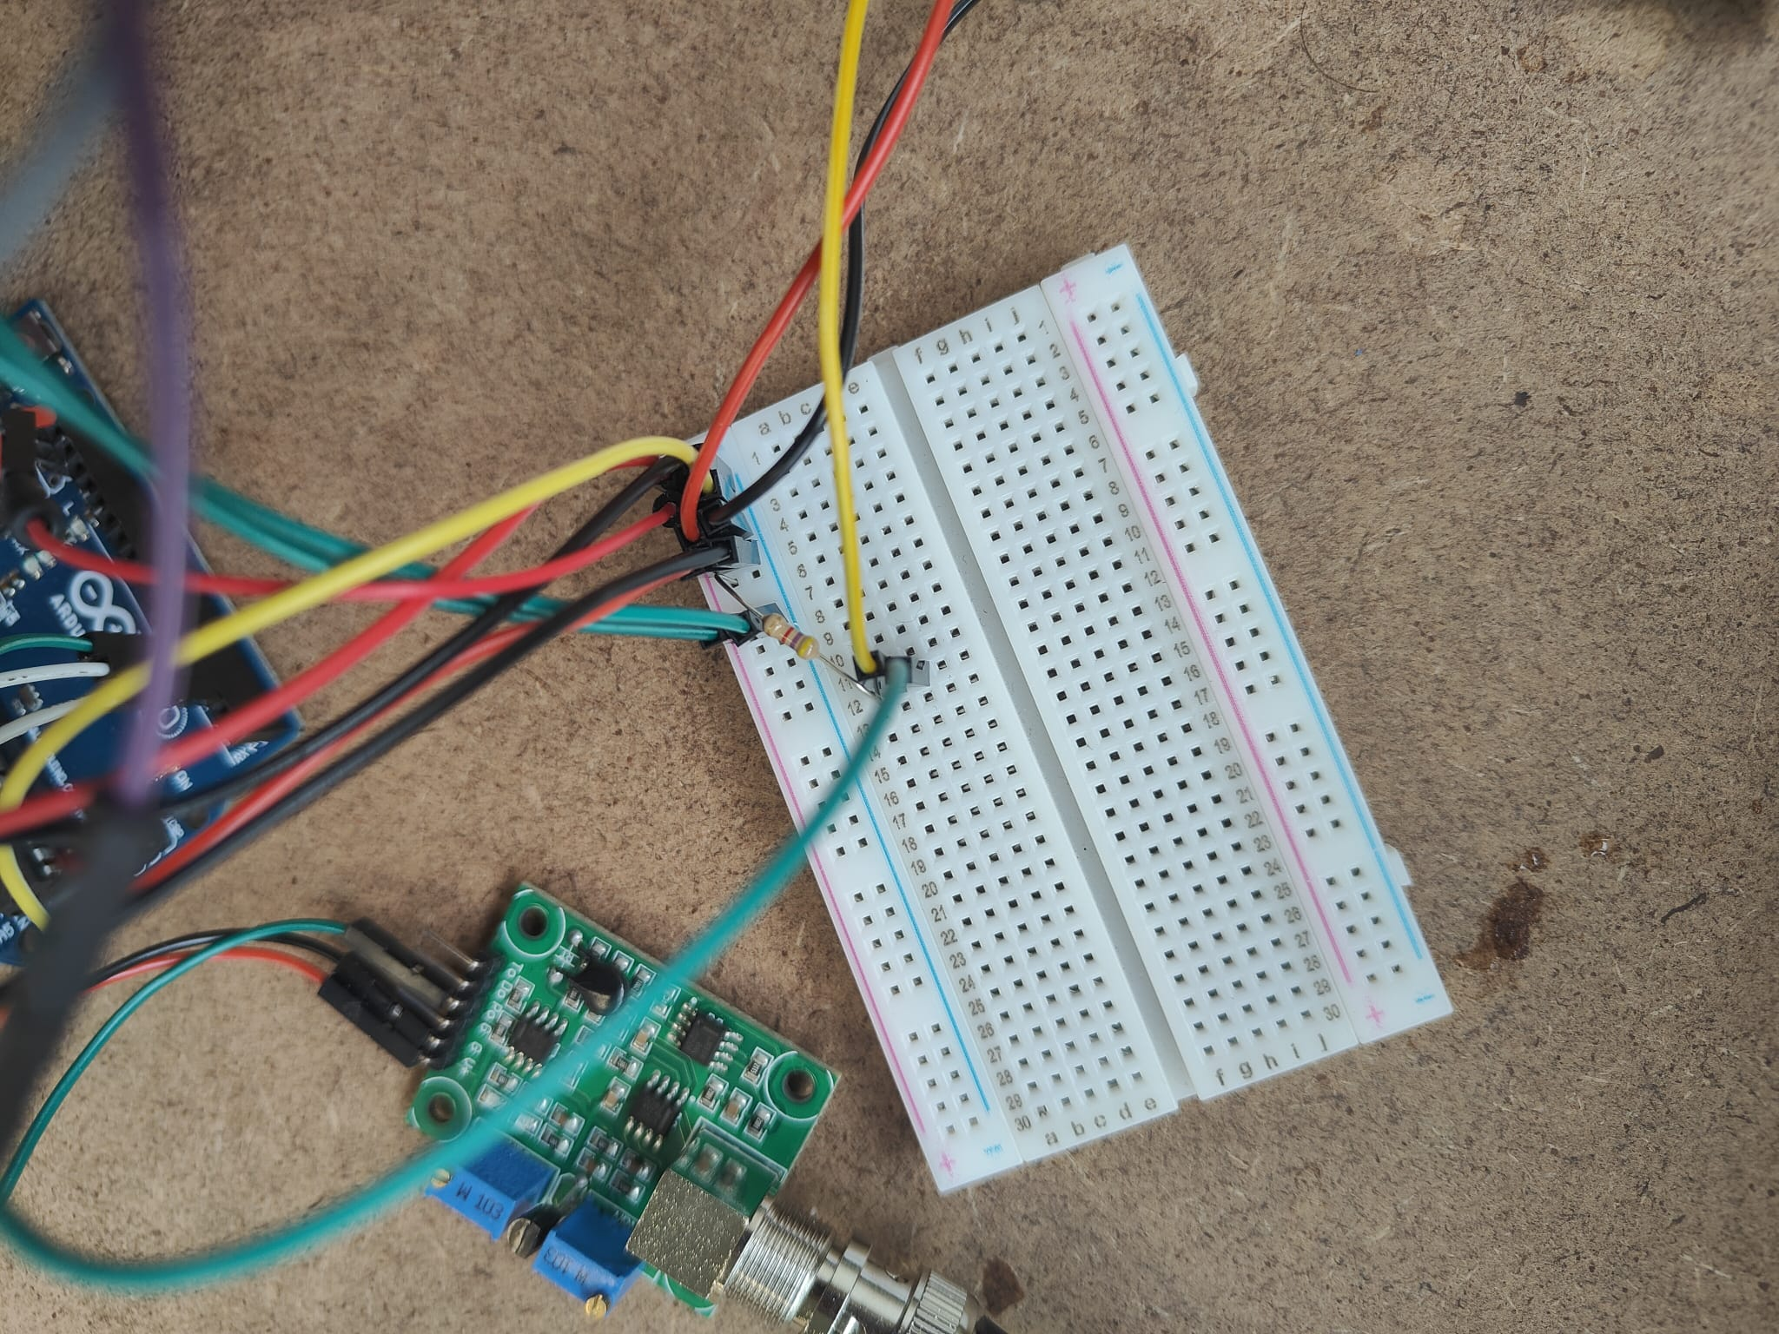

Figure2: Clear picture of breadboard connections

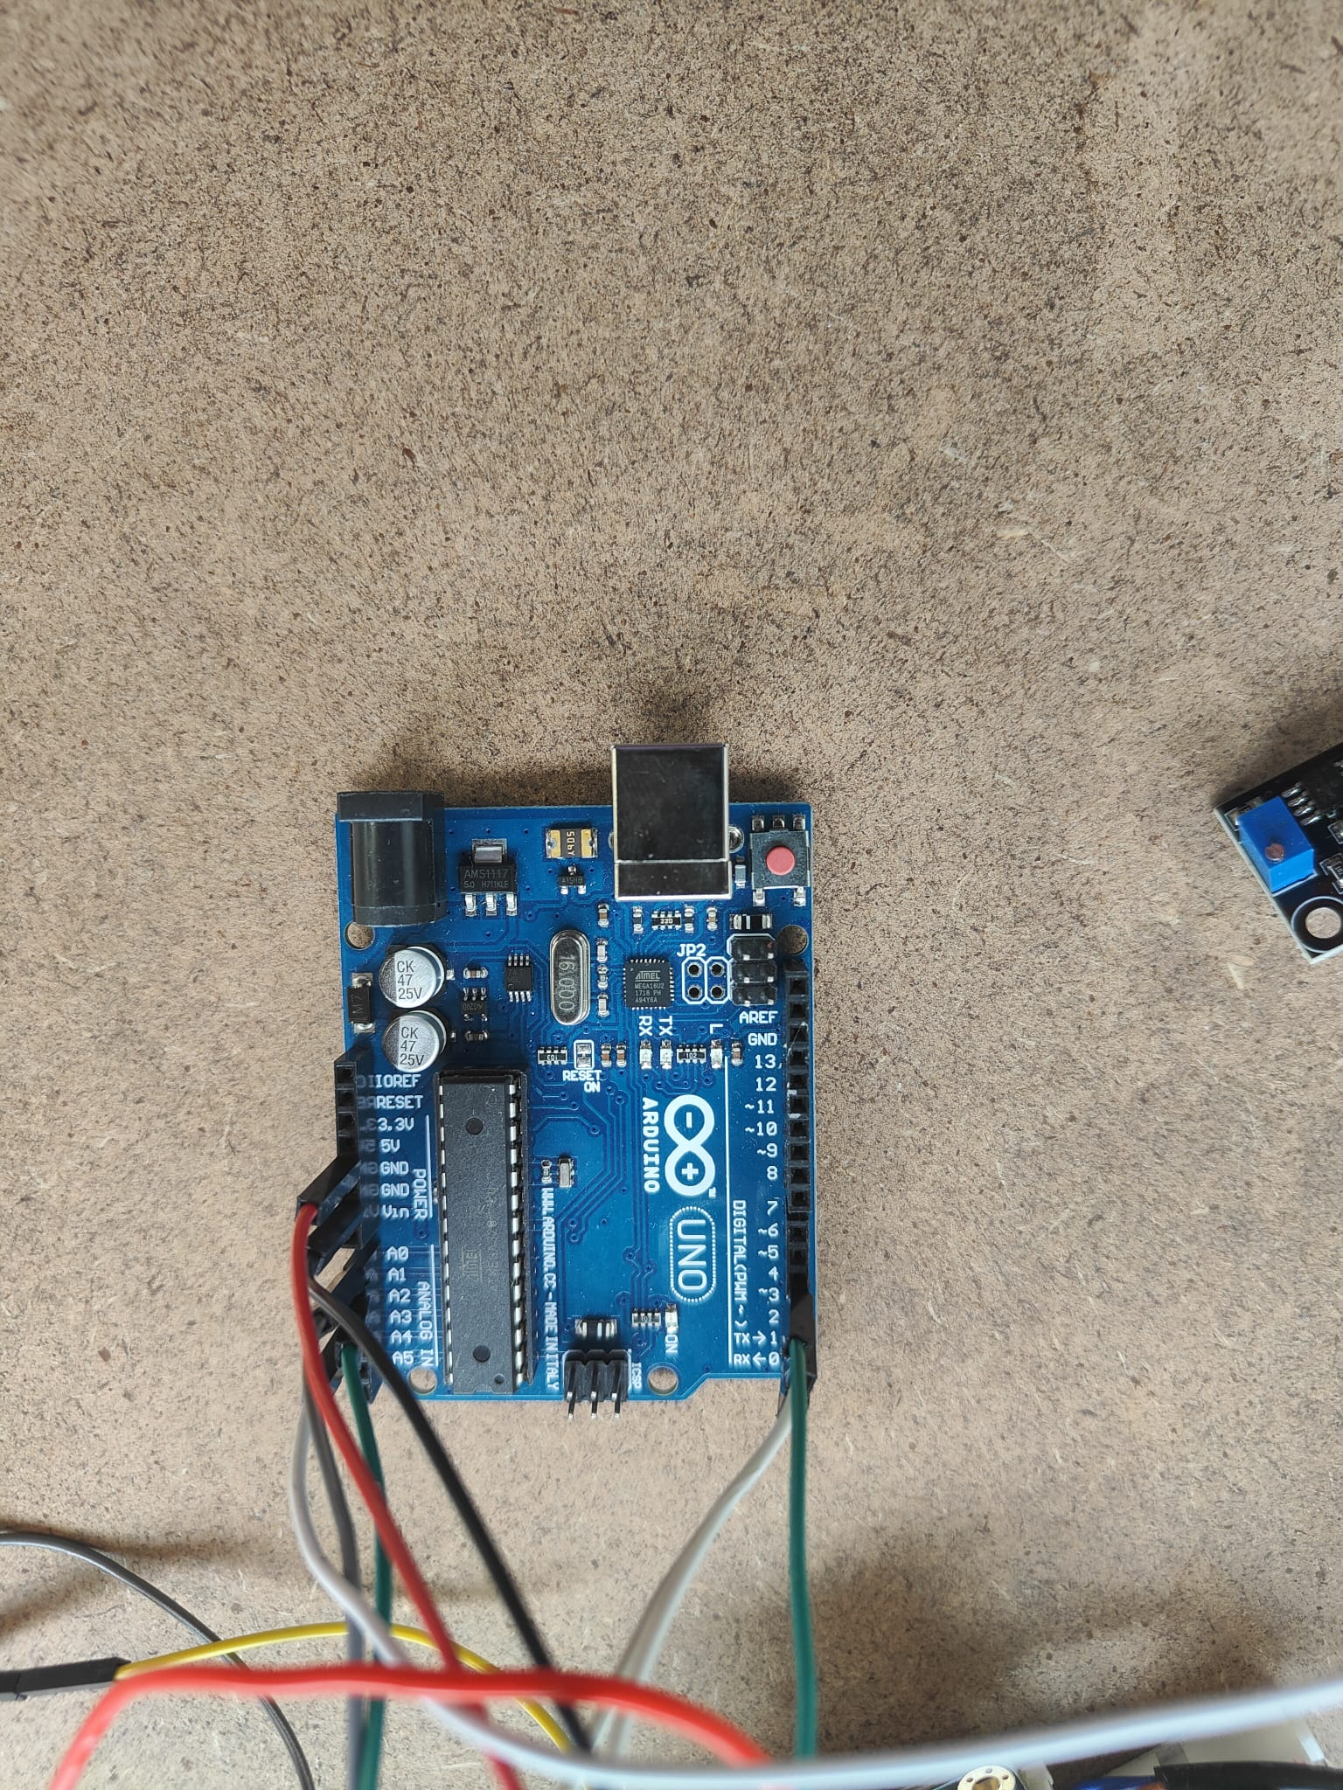

Figure3: Clear picture of Arduino connections.

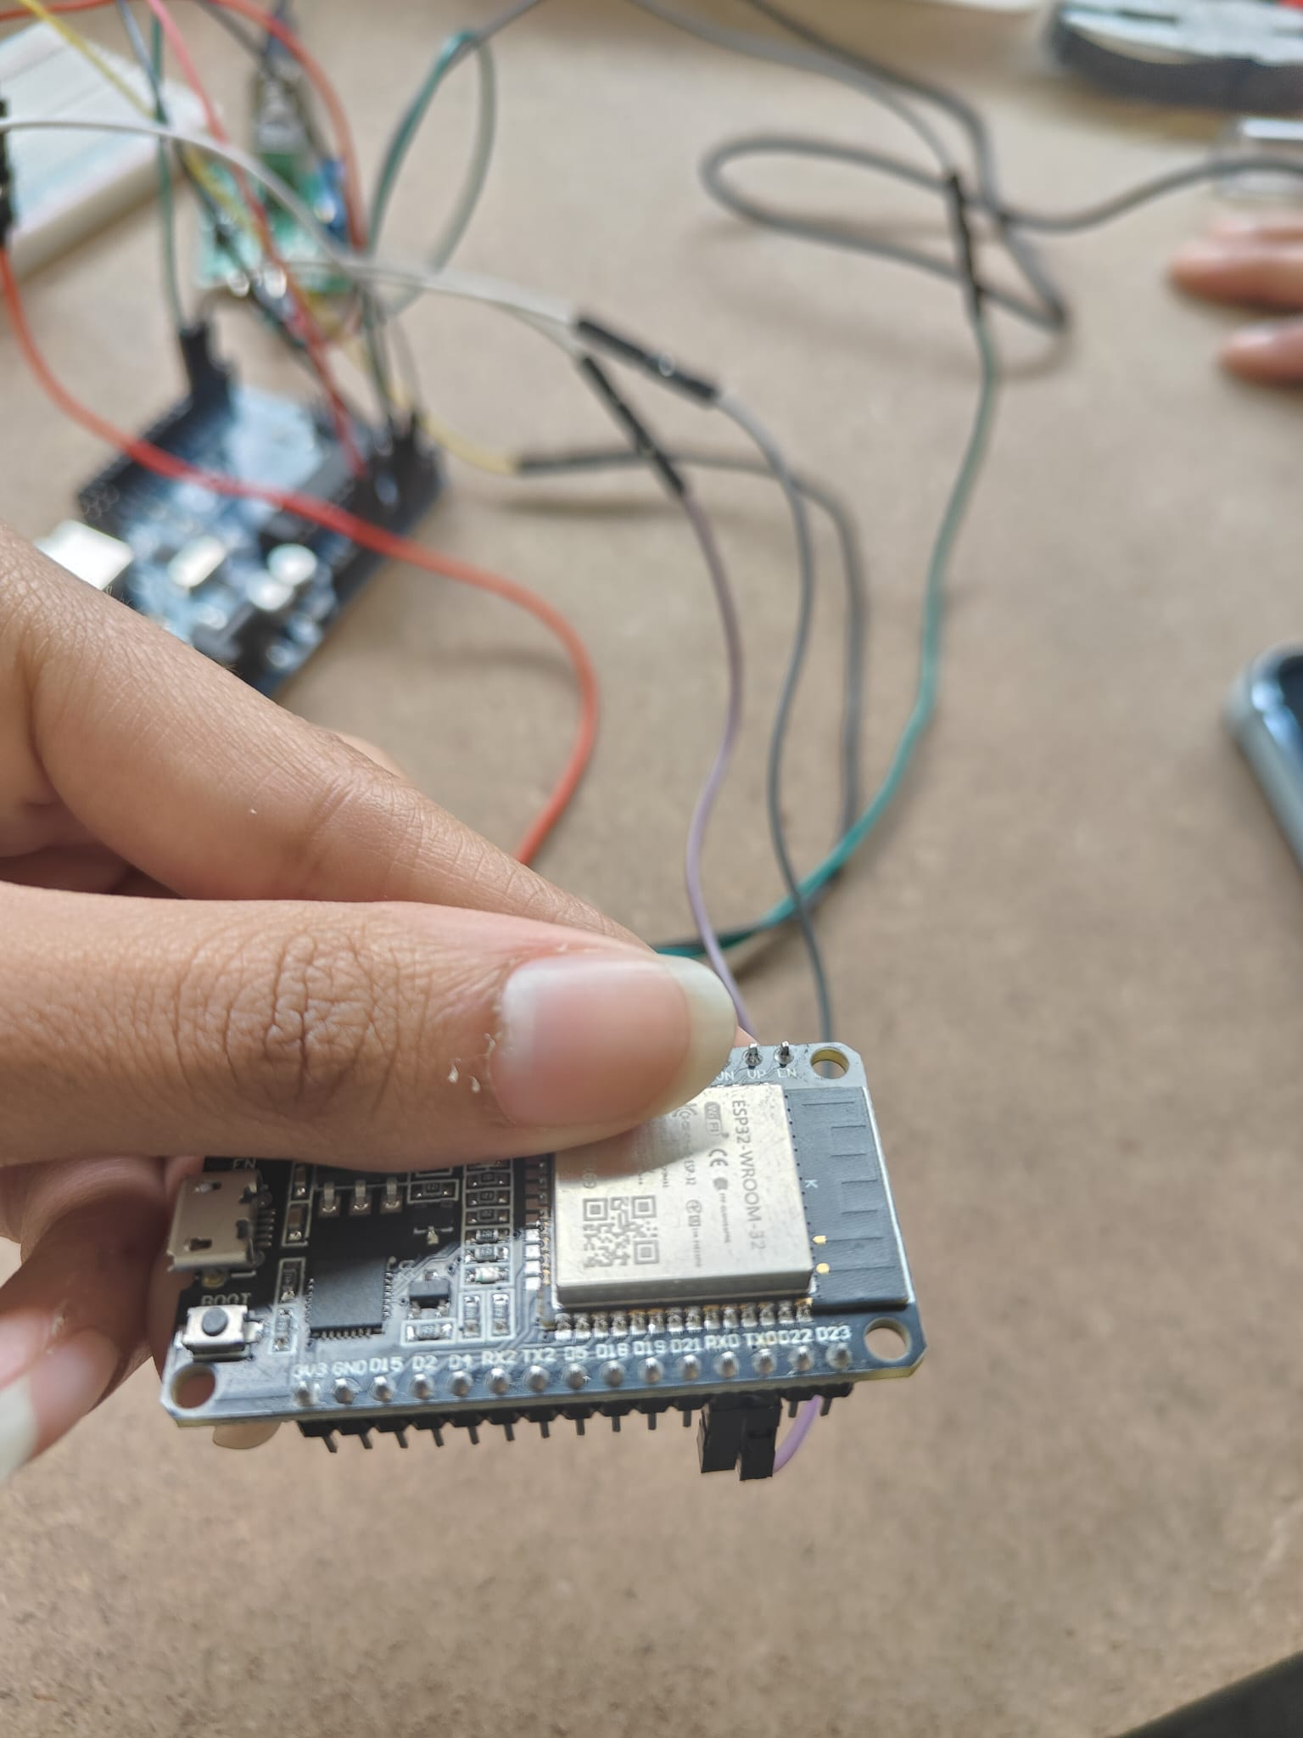

Figure4: Clear picture of ESP32 connections

# 

# 

# 

# Results:

In this section, we present the outcomes of our data collection and transmission process using the ESP32 as a WiFi module to transfer sensor data from the Arduino to ThingSpeak. The sensors utilized in our project include turbidity, total dissolved solids (TDS), temperature, and pH.

Turbidity:

* We successfully captured turbidity data using the turbidity sensor connected to the Arduino.
* The turbidity values were transmitted in real-time to ThingSpeak via the ESP32 WiFi module.
* Visualizations of turbidity trends over time were created on ThingSpeak, providing insights into water clarity levels.

Total Dissolved Solids (TDS):

* TDS measurements were obtained using the respective sensor integrated with the Arduino.
* The TDS data was transmitted wirelessly to ThingSpeak using the ESP32.
* Visual representations of TDS fluctuations were generated on ThingSpeak to monitor changes in water quality.

Temperature:

* Temperature readings were acquired using a temperature sensor interfaced with the Arduino.
* The temperature data was transmitted seamlessly to ThingSpeak via the ESP32 module.
* Graphical representations of temperature variations were generated on ThingSpeak to track changes in environmental conditions.

pH:

* pH measurements were obtained through a pH sensor connected to the Arduino.
* The pH data was transmitted in real-time to ThingSpeak using the ESP32 WiFi module.
* Graphical depictions of pH levels were produced on ThingSpeak to monitor acidity or alkalinity variations in the water samples.

The below are the values we got while measuring for accuracy. We found out that as TDS value increases it is difficult to reach the accuracy

| With sensors | Temperature | TDS | pH |
| --- | --- | --- | --- |
| Bottled water | 25.12 | 125 | 7.14 |
| Tap water | 24.12 | 147 | 6.67 |
| Lemon water | 24.31 | 441 | 2.61 |
| Soap | 24.31 | 476 | 8.28 |
| With measurement devices |  | | |
| Bottled water | 25.2 | 158 | 7.09 |
| Tap water | 24.12 | 229 | 6.62 |
| Lemon water | 24.1 | 706 | 2.8 |
| Soap | 23.6 | 676 | 8.17 |

Here’s the results for accuracy:

| Accuracy | Temperature | TDS | pH |
| --- | --- | --- | --- |
| Bottled water | 99.68% | 79.11% | 99.29% |
| Tap water | 100% | 64.19% | 99.24% |
| Lemon water | 99.12% | 62.46% | 93.21% |
| Soap | 96.99% | 70.41% | 98.65% |

Overall, the integration of the ESP32 WiFi module with the Arduino facilitated the seamless transmission of sensor data to ThingSpeak, enabling the visualization of sensor readings in real-time. These visualizations serve as valuable tools for monitoring water quality parameters and detecting any abnormalities or trends over time.

# Discussion:

Four parameters namely TDS, pH, turbidity, temperature, are measured using the experimental setup. The setup is connected to the Thinks Speak plat- form. The measured results are compared with drinking water quality standards defined by WHO. Further, experiments were conducted by placing the sensors in the different solutions of water collected in the university premises. Further, to demonstrate the working of the system, and the various options for data analysis, measured quantity of contaminants such as salt and soil are mixed with 350 ml of pipe water and testing is performed. Things Speak has the dashboard with widgets to view the results of data collected in the cloud.

The other feature is creation of events, based on measured parameter values. The events stored can be programmed to automatically send SMS, email, and other forms of alerts to the user whenever any parameter exceeds the threshold limit.

So what does this mean? Someone who has no knowledge of how this sensor works what should they take away from your report.

In our experiment, we utilized a setup equipped with sensors to measure four important parameters of water quality: Total Dissolved Solids (TDS), pH level, turbidity, and temperature. These measurements were then transmitted to the ThingSpeak platform for analysis and visualization. We compared the recorded data against the drinking water quality standards set by the World Health Organization (WHO) to assess the suitability of the water samples. Additionally, we conducted experiments by placing the sensors in various water sources across our university campus to evaluate their quality.

To demonstrate the functionality of our system and its capability for data analysis, we performed tests where we intentionally introduced contaminants such as salt and soil into a controlled amount of piped water (350 ml) and observed the corresponding changes in the measured parameters. The ThingSpeak platform facilitated this process by providing a dashboard with customizable widgets, allowing us to easily view and interpret the collected data stored in the cloud.

One notable feature of our system is its ability to trigger events based on predefined threshold values of the measured parameters. This means that if any of the parameters exceed or fall below certain critical levels, the system can automatically generate alerts or notifications, enabling timely intervention to address potential water quality issues. This aspect is particularly crucial for ensuring continuous monitoring and maintenance of water quality standards, even in the absence of direct human supervision.

Overall, our report demonstrates the practical application of sensor technology for water quality assessment and management, showcasing how such systems can contribute to ensuring access to safe and clean drinking water by monitoring key parameters and facilitating proactive measures to safeguard public health and environmental sustainability.

References:

1. World Health Organization. (2023). Drinking-water. Fact sheet.<https://www.who.int/news-room/fact-sheets/detail/drinking-water>
2. IISD. (2019). UNEP Highlights Funding Needs for Water Quality Monitoring. SDG Knowledge Hub.<https://sdg.iisd.org/news/unep-highlights-funding-needs-for-water-quality-monitoring/>
3. Environmental Protection Agency. (n.d.). Clean Water Act (CWA) compliance monitoring. Retrieved from<https://www.epa.gov/compliance/clean-water-act-cwa-compliance-monitoring>